Analysis of the Relationship between Cable Spool Diameter and Rib Minor Axis Length

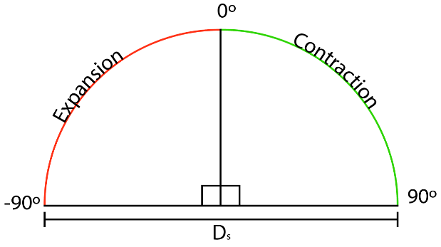One constraint on the design was the capability of the servos to rotate 180 degrees overall. The result of this was that the total amount of spooled cable we could contract to perform the flapping action of the fish was constrained to be $L_{0}=\frac{πD_{s}}{2}$ where $L_{0}$ is the total length of contractable string and $D_{s}$ is the diameter of the spool. In addition, to flap the fish in both directions, the wire must be able to contract in one direction and extend in the other, reducing the length of contraction in one direction to $L_{1}=\frac{πD_{s}}{4}$.

Figure : Cable Length dependent on Servo Angle Constraint

For perspective, with a reasonable $D_{s}=65 mm$, we are constrained to a $L_{1}=51 mm≈50 mm$. It is then important to understand the relationship between the contractions of the cables and the resulting curvature of the fish.

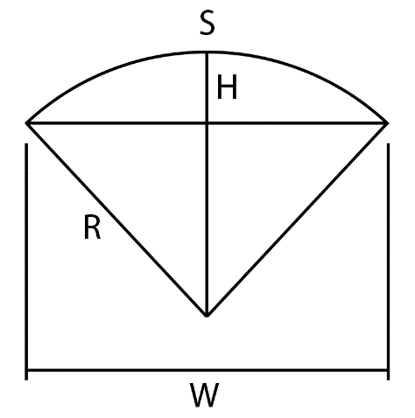We begin by placing the fish in desired curvature for an estimate of the dimensions. We found the length of the fish pillow, $L_{f}=900 mm$, the distance between the tips when the pillow was curved, $l_{c}=720 mm$, and the height of the centerline of the curved pillow, $h_{c}=230 mm$. With any single arc, there exists an associated angle and radius of curvature such that $S_{arc}=r_{c}θ_{c}$. From the following diagram and the Pythagorean Theorem, we can perform the following analysis to find an equation for the radius of curvature:

$$R^{2}={\left(R-H\right)}^{2}+{\left(\frac{W}{2}\right)}^{2}$$

$$R^{2}=R^{2}-2RH+H^{2}+\frac{W^{2}}{4}$$

$$R=\frac{H}{2}+\frac{W^{2}}{8H}$$

$$W=l_{c}=720 mm, H=h_{c}=230 mm→R≈400 mm$$

We can then also determine that the angle that the arc covers:

Figure : Geometry of Radius of Curvature

$$θ_{c}=\frac{S_{arc}}{r_{c}}=\frac{L_{f}}{R}=2.25 rad$$

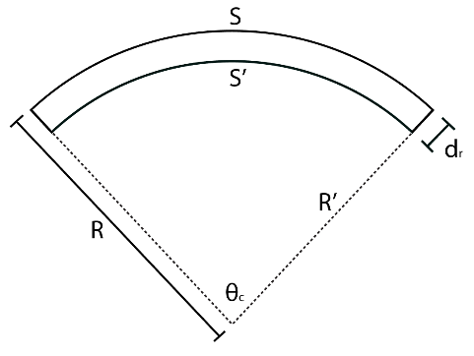Relating this analysis to the cable contraction and using the previous equation for arc length, we can relate the contracted amount of cable to the length of the fish and the distance between the centerline of the fish and the cable line. Intuitively, the closer the cable line is to the center, the less cable needs to be contracted to bend the fish. Since the angle of curvature is the same, and the cable length when there is no curve is equal to the length of the fish, we can say that: $S-S^{'}=\left(R-R^{'}\right)θ$ which reduces to $L_{1}=d_{r}θ_{c}$ where $l_{1}$ was previously defined as the constrained contractible length of cable in one direction and $d_{r}=\frac{L_{1}}{θ_{c}}≈20 mm$ is the distance from the centerline of the fish to the cable line or the minor axis length of the fish rib.

Figure : Difference in Radius of Curvature with given Change in Arc Length

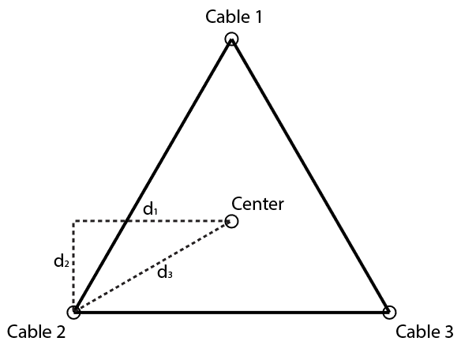It is important to note, however, that, because of the geometry of our three cable system, the lower cable lines do not lie on the minor axes, instead lying on the points of an equilateral triangle whose center is the centerline. Figure 4 illustrates the relationship between $d_{r}$ and the distance from the cable line to the center. The relevant distance $d_{3}$ for the design of our rib part is given by $d_{3}=\frac{2}{√3}d_{1}=\frac{2}{√3}d_{r}≈25 mm$. One could potentially make the observation that the distance $d_{3}$ would be such that $d_{3}=d_{r}$, however, if we take a bird’s eye view of the system, we can see very obviously that the height of the cable lines, the point of intersection between the minor axis and major axis, does not change the distance from the cable lines to the centerline from that perspective. We are allowed to use this perspective on the assumptions that Cable 2 and Cable 3 lie in the same horizontal plane and that they are symmetric about the vertical axis passing through the centerline. As a result, we have found the length of the minor axis of the rib: $L_{r}=2d_{r}$. We can also determine the length of the major axis if we design the cable symmetry to be an equilateral triangle. $L_{R}=2d_{R}=2\frac{\sqrt{3}}{2}d_{r}=\sqrt{3}d_{r}$. We can also define $L_{r}$ in symbolic form and make an approximation of the ratio of axis length to spool diameter:

Figure : Cross-Section of Fish Rib displaying Constraint on Distance from Center to Cable Lines

$$d_{r}=\frac{L_{1}}{θ_{c}}=\frac{\frac{πD_{s}}{4}}{\frac{L_{f}}{R}}≈0.35*D_{s}$$

So for a given $D_{s}$ and desired curvature, the resulting horizontal component of the distance between a cable line and the centerline is about a third the diameter of the spool.